Minister: Rev. William Brown
E-mail: fccbedfordwill@gmail.com
Choir Director: Lillie Judge
E-Mail: ljudgefcc@gmail.com
Organist: Mary Ruth Yates
Church Office Hours: Monday-Thursday: 9:00 am - 2:00 pm
A/V Technician: Duncan Kane
Administrative Assistants:
Mitzi Flynn: Monday, Dawn Manke: Tuesday, Wednesday, & Thursday
Bookkeeper: Linda Smith
E-mail: shawswick63@gmail.com
Custodian’s Hours: Monday-Wednesday: 8:00 am - 11:00 am, Sunday: 1 hour
Custodian: Steve Harrell
Camp Manager: Chuck Bair
E-Mail: manager@campbedford.com
Web Page: firstccbedford.org
Camp Bedford Web Page: campbedford.com
********************************************************************************************
Prayer List: Beve Austin, Mike Babb, Paula Beaton, Karen Briscoe, Brandy Busz, Levi Chisholm, Mark Clemsey, Leo Coulter, Tina Corum, Kathy Davis, Lisa Drude, Pat East, Chantell Emberton, Aaron Evans, Bob Evans, Ariene Gilbert, Carson Grover, James Hackney, Karen Hackney, Liam Harting, Gloria Hilkey, Ethan Holseapple, Ainsley Jefferies, Van Kavanaugh, Defne Leonard, Danny Lyons, William Metz, Carol Mifflin, Sheila Miskuf, Patricia Morris, Charity Henderson Parker, Shelly Perrson, Betty Robbins, JK Robbins, Mary Beth Sieman, Sydney Sowders, Nancy Strunk, Candy Sykes, Greg VanCleave, Sandy Weldon, Linda White, Mark Wingo, Nathan Witt, Roger Wykoff

Those away from home serving the church, in military, civil service, education and work.

Those unable to be with us in Worship: Vivian Fishel, Barbara Hall, Jacob Householder, Shirley McMunn, Laverne Speer, Carolyn Tumey, Betty Wagoner, Jimmy Waggoner.

Please advise Elder Susan Maxwell-Lewis or the
church office of any prayer concerns. or updates.
You may also fill out a pew card & drop it in the offering plate.

First Christian Church (Disciples of Christ)
1101 15th Street www.firstccbedford.org 812-275-4497
Bedford, IN 47421 office@firstccbedford.org

Reaching Outward to Connect People with God’s Abundance

April 16, 2023

April 16, 2023 SERVICE OF WORSHIP 10:30 am

Please complete the cream-colored card located in the back of each pew and place it in the offering plate. Help us by filling out the card as completely as you can. You may also use the card to inform the office of any prayer requests, joys, concerns, upcoming events, changes, etc.
Turn off cell phones as they may interfere with the live stream. Thank you.

*Please Stand (as you are able)
*******************************************************************************************

Prelude Amazing Grace - Gordon Young

Welcome and Announcements Rev. William Brown

*Call to Worship Worship Leader
Leader: Protect us, O God,
All: For in you we take refuge.
Leader: The LORD is our chosen portion;
All: Because of this we have a goodly heritage.
Leader: Let us bless the LORD, who gives us counsel;
All: We will keep the Lord always before us, We shall not be moved.
Leader: Therefore our hearts are glad, and our souls rejoice;
All: For in your presence there is fullness of joy.

*Opening Hymn He Lives! #226 (vs 1 & 2)

Pastoral Prayer Rev. William

Lord’s Prayer All

Our Father, who art in heaven, hallowed be thy name. Thy kingdom
come. Thy will be done on earth as it is in heaven. Give us this day
our daily bread and forgive us our sins as we forgive those who
have sinned against us. And lead us not into temptation but deliver
us from evil. For thine is the kingdom, the power and the glory
forever. Amen.

Scripture John 20:19-31 Worship Leader

Anthem Lift High the Cross – arr by Hal H, Hopson Chancel Choir

Proclamation Belief Rev. William

*Hymn of Discipleship God, Who Touches Earth with Beauty #514 (vs 1, 3 & 5)

*Invitation to Giving Rev. William

*Doxology All
Praise God from whom all blessings flow;
Praise him, all creatures here below;
Praise him above, ye heavenly host:
Praise Father, Son, and Holy Ghost. Amen.

*Prayer of Dedication Elder

Communion Hymn Come, Share the Lord #408 (vs 1 & 2)

Invitation to Christ’s Table Rev. William

Prayer for the Bread and Cup Elder

Communion Music O Master, Let Me Walk With Thee - Gordon Young

Words of Institution Rev. William

Taking of the Bread and Cup Together

Passing of the Peace Pastor: Peace be with you All: And also with you

*Closing Hymn Great is Thy Faithfulness #86 (vs 1 & 3)

*Blessings and Benediction

*Postlude Christ is Alive! Let Christians Sing! - Albrecht

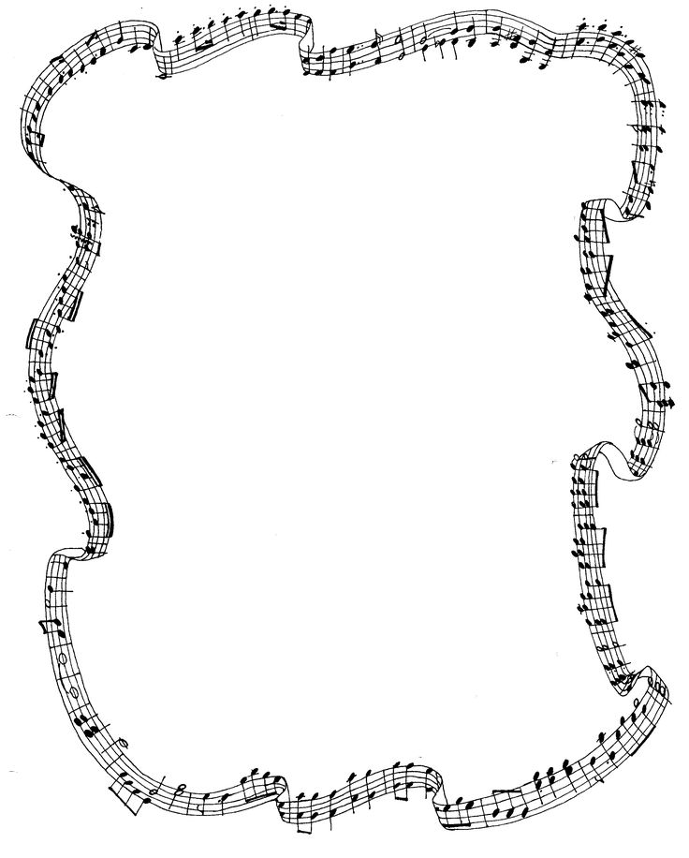
Lift High the Cross
Arranged by Hal H. Hopson

Lift high the cross, the love of Christ proclaim
till all the world adores his sacred name.

Come, Christians, follow where our Savior trod,
the Lamb victorious, Christ, the Son of God.

Lift high the cross, the love of Christ proclaim
till all the world adores his sacred name.

Each newborn servant of the Crucified bears
on the brow the seal of Christ who died.

Lift high the cross, the love of Christ proclaim
till all the world adores his sacred name.

Alleluia! Alleluia! Alleluia! Alleluia!
Alleluia! Alleluia! Alleluia!

O Lord, one lifted on the glorious tree,
your death has brought us life eternally.

Lift high the cross, the love of Christ proclaim
till all the world adores his sacred name.

So shall our song of triumph ever be;
Praise to the Crucified for victory.

Lift high the cross, the love of Christ proclaim
till all the world adores his sacred name.

Lift high the cross. Alleluia! Alleluia! Alleluia!

NOTES:

________________________________________________________________

________________________________________________________________

________________________________________________________________

________________________________________________________________

________________________________________________________________

________________________________________________________________

________________________________________________________________

________________________________________________________________

________________________________________________________________

________________________________________________________________

________________________________________________________________

________________________________________________________________

________________________________________________________________

________________________________________________________________

________________________________________________________________

________________________________________________________________

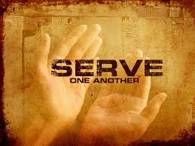

SERVING SCHEDULE: April

Greeters
15th St Linda Smith
K St Ron Bell
Canopy Treva Hooten

Coffee Hour Sunday Morning
Coffee and treats starting
at 9:30 am.
Sign up at the Welcome Table if you would like to contribute treats.

Board of Directors Meeting
The Board of Directors Meeting will be on Tuesday, April 18, 2023. It will start at 5:30 pm in the Fellowship Hall. The meeting is open to anyone in the congregation.

Coffee Hour Sunday Morning
Coffee and treats starting
at 9:30 am.
Sign up at the Welcome Table if you would like to contribute treats.

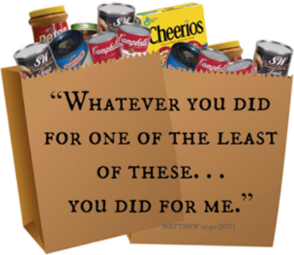
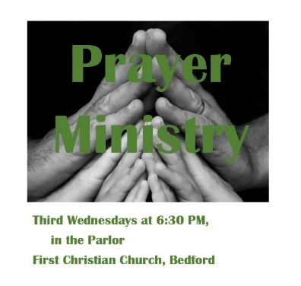
Outreach Committee Ministry

We are collecting FEED MY SHEEP during the month of APRIL
for L.I.F.E. Pantry.
Please place all packages in the baskets located in the foyer. Any food or items you wish to donate are welcome any month.

